**UNIT 13 : FESTIVALS**

**Read** (Trang 124-126 SGK Tiếng Anh 8)

**I. New words:**

1. **volcano (n):** núi lửa **volcanic (adj):** thuộc về núi lửa **volcanically (adv): volcanist (n)**: nhà nghiên cứu núi lửa
2. pour (v): phun tròa, tuôn trào
3. fly- flew - flown (v): bay
4. wharf (n): cảng
5. valley (n): thung lũng
6. prison (n): nhà tù
7. carve (v): khắc
8. situate (v): tọa lạc
9. souvenir (n): quà lưu niệm
10. Statue of Liberty (n) : tượng nữ thần tự do

Christmas is an important festival in many countries around the world.

(*Giáng sinh là một ngày lễ quan trọng ở nhiều nước trên thế giới.*)

**Bài nghe:**

**Hướng dẫn dịch:**

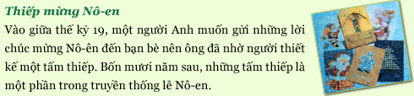

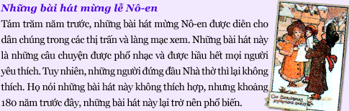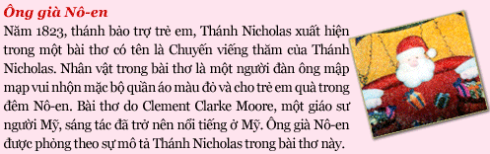

**1. Complete the table.**

**(Hoàn thành bảng.)**

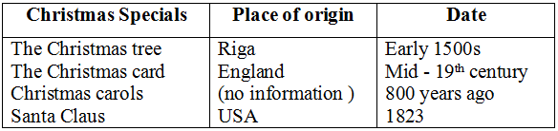

**2. Answer the questions.**

**(Trả lời các câu hỏi.)**

**a)** How long ago did the Christmas tree come to the USA?

=> The Christmas tree came to the USA in the 1800s.

**b)** Why did the Englishman have someone design a card?

=> Because he wanted to send Christmas greeting to his friends.

**c)** When were Christmas songs first performed?

=> Christmas songs were first performed 800 years ago.

**d)** Who wrote the poem A Visit from Saint Nicholas?

=> An American professor named Clement Clarke Moore wrote A visit from Saint Nicholas.

**e)** What is Santa Claus based on?

=> Santas Claus is based on the description of Saint Nicholas in the poem.